Supplementary Material

# Supplementary Figures

For more information on Supplementary Material and for details on the different file types accepted, please see [here](http://home.frontiersin.org/about/author-guidelines#SupplementaryMaterial). Figures, tables, and images will be published under a Creative Commons CC-BY licence and permission must be obtained for use of copyrighted material from other sources (including re-published/adapted/modified/partial figures and images from the internet). It is the responsibility of the authors to acquire the licenses, to follow any citation instructions requested by third-party rights holders, and cover any supplementary charges.

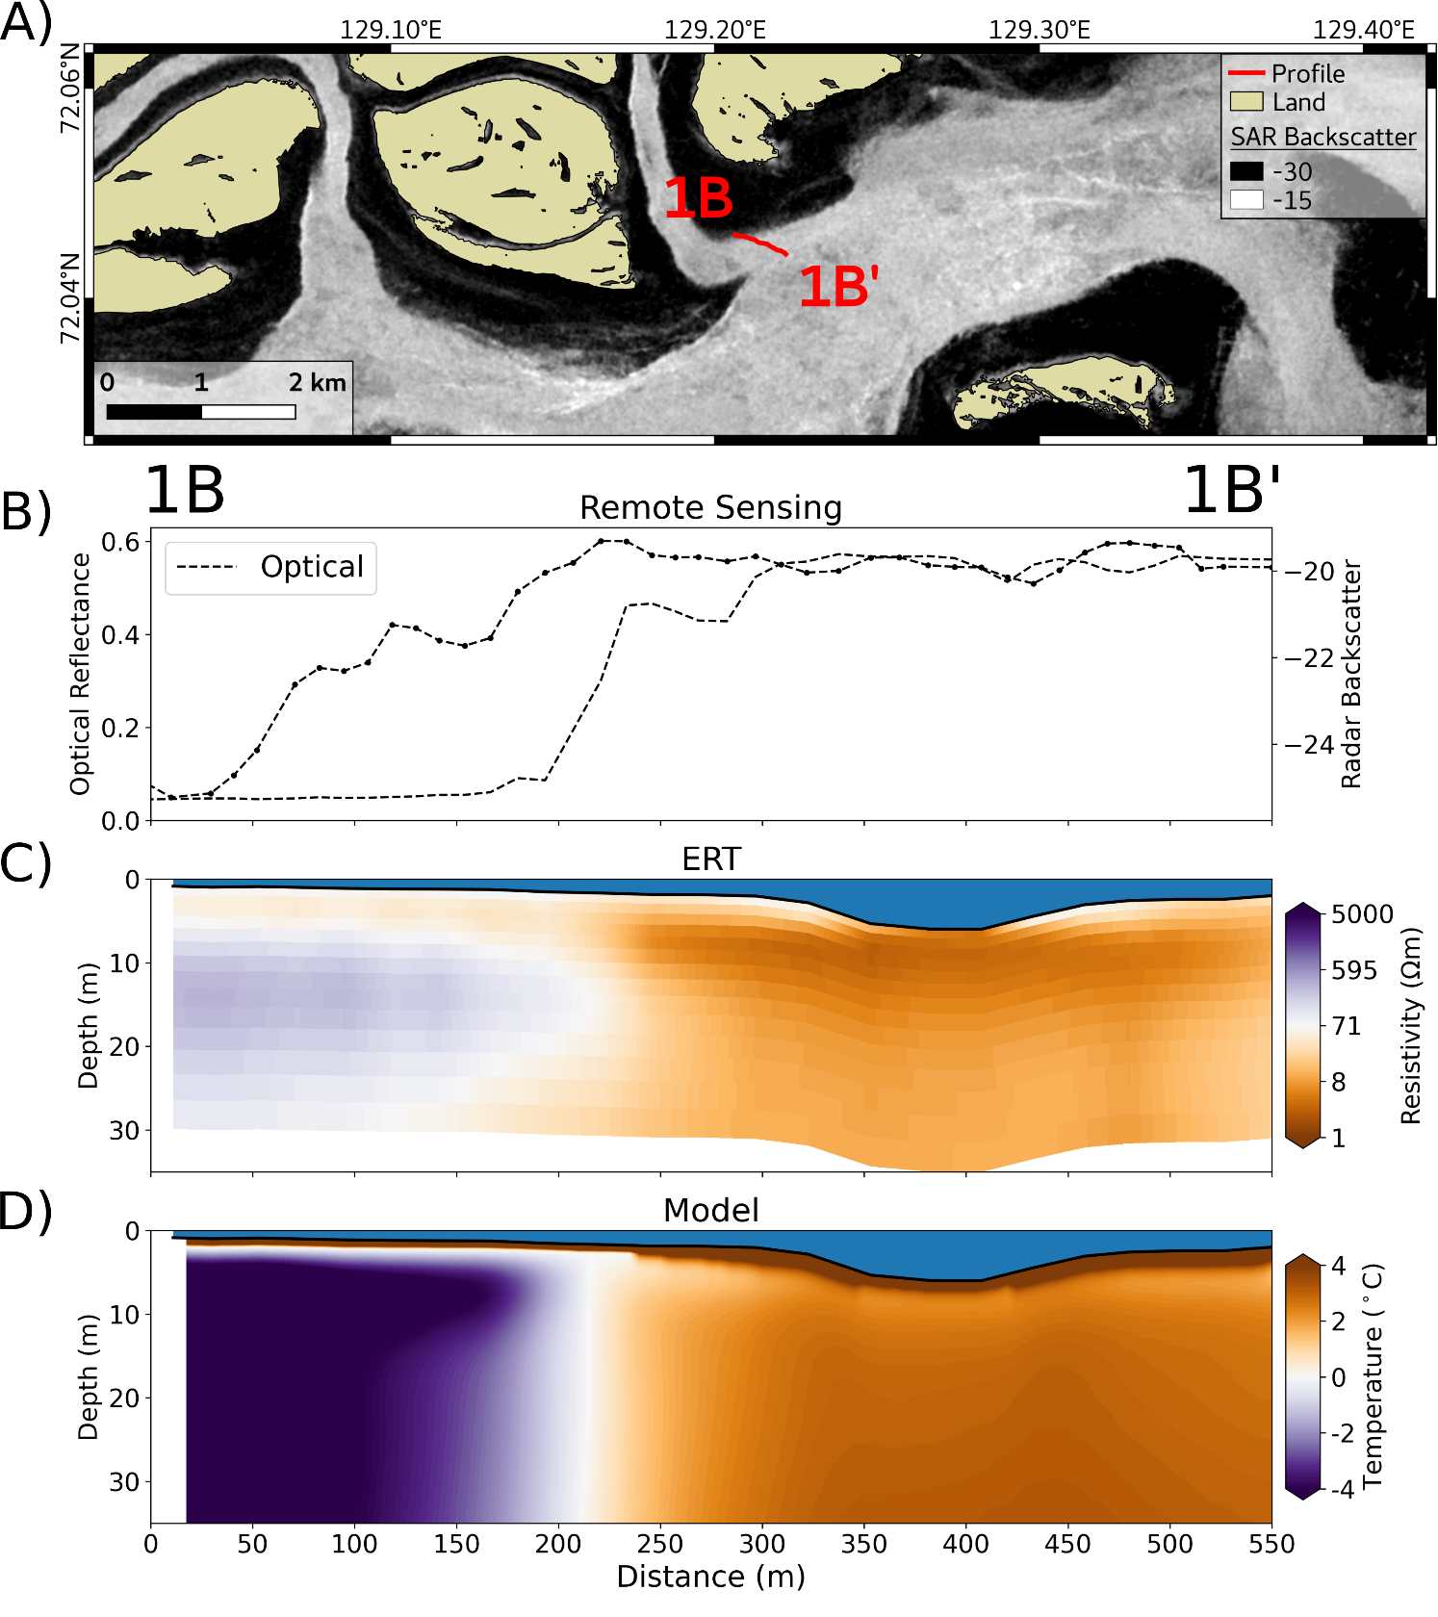

**Supplementary Figure 1**: Profile 1B - 1B’ (for the location see Figure 1). **A**) GPS track of the ERT profile on top of the SAR Sentinel-1 median winter image showing the bedfast (dark) and serpentine (bright) ice. **B**) Extracted optical reflectance and SAR backscatter along the profile. **C**) Cross section of the inverted ERT resistivity along the profile. **D**) Modelled sediment temperature along the profile.

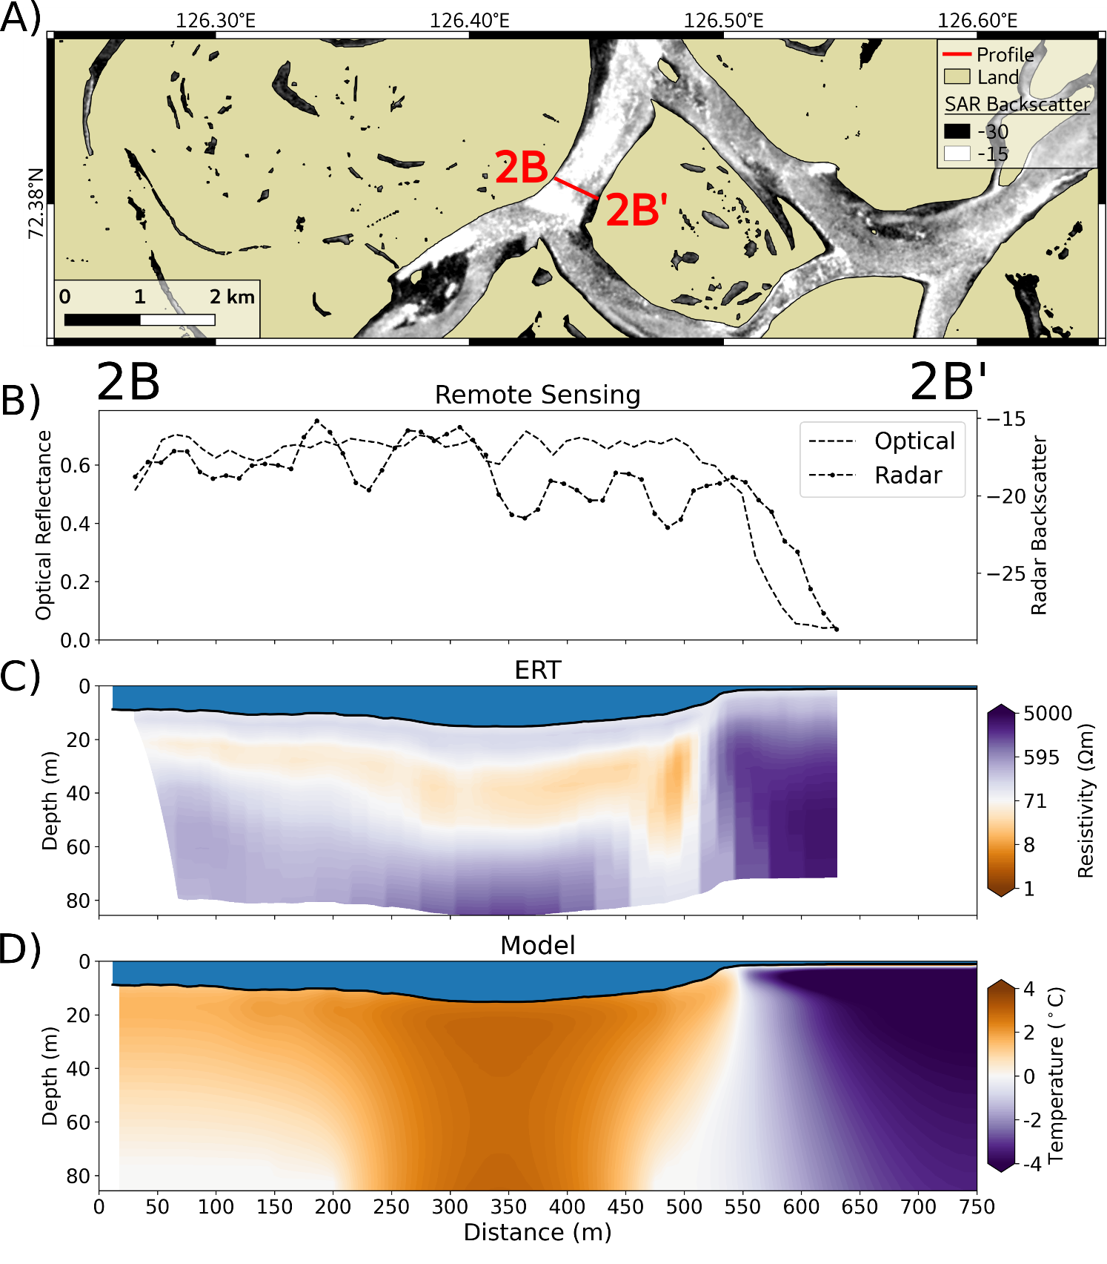

**Supplementary Figure 2**: Profile 2B - 2B’ (for the location see Figure 1). **A**) GPS track of the ERT profile on top of the SAR Sentinel-1 median winter image showing the bedfast (dark) and serpentine (bright) ice. **B**) Extracted optical reflectance and SAR backscatter along the profile. **C**) Cross section of the inverted ERT resistivity along the profile. **D**) Modelled sediment temperature along the profile.

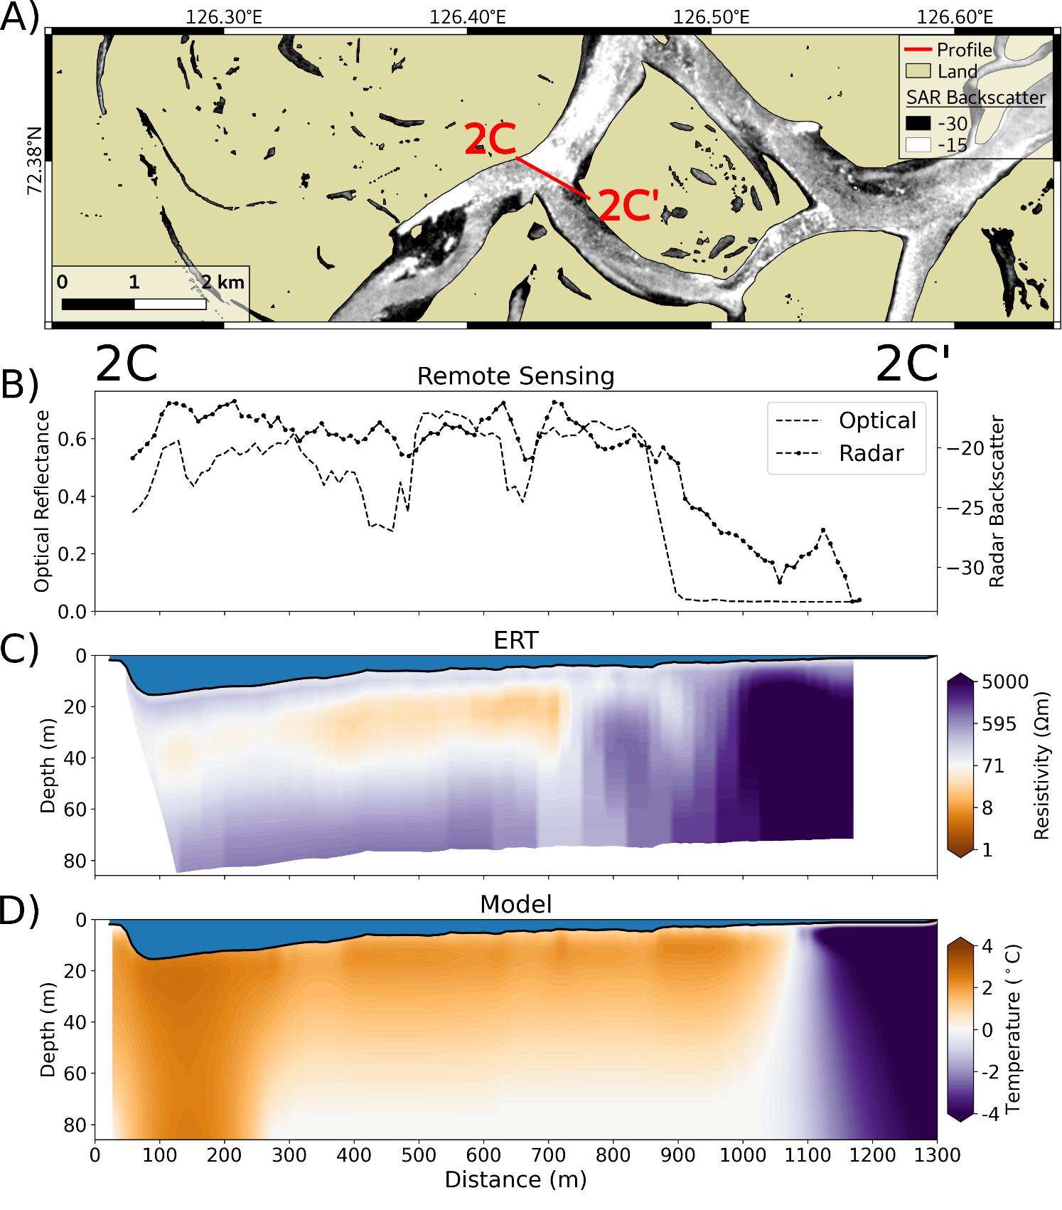

**Supplementary Figure 3**: Profile 2C - 2C’ (for the location see Figure 1). **A**) GPS track of the ERT profile on top of the SAR Sentinel-1 median winter image showing the bedfast (dark) and serpentine (bright) ice. **B**) Extracted optical reflectance and SAR backscatter along the profile. **C**) Cross section of the inverted ERT resistivity along the profile. **D**) Modelled sediment temperature along the profile.

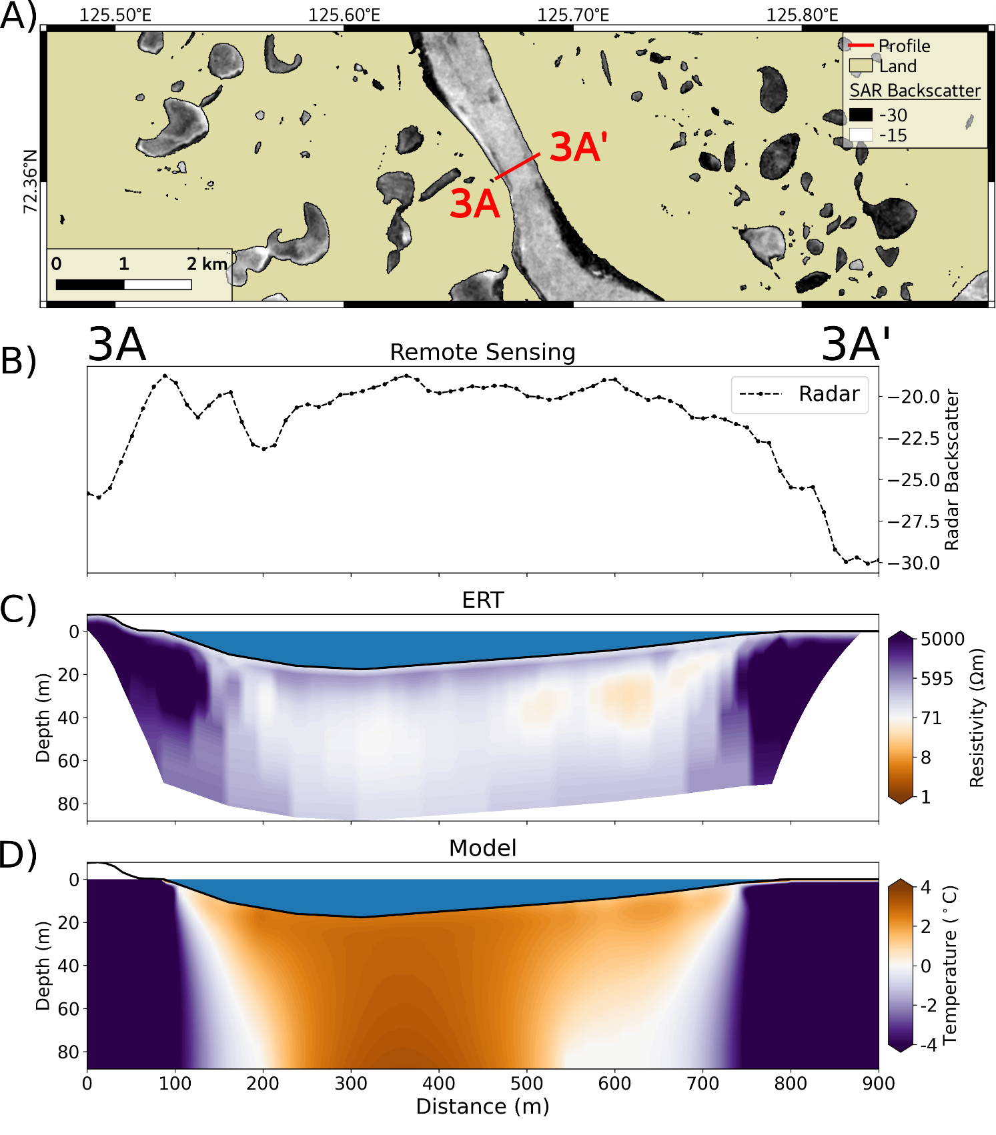

**Supplementary Figure 4**: Profile 3A - 3A’ (for the location see Figure 1). **A**) GPS track of the ERT profile on top of the SAR Sentinel-1 median winter image showing the bedfast (dark) and serpentine (bright) ice. **B**) Extracted optical reflectance and SAR backscatter along the profile. **C**) Cross section of the inverted ERT resistivity along the profile. **D**) Modelled sediment temperature along the profile.

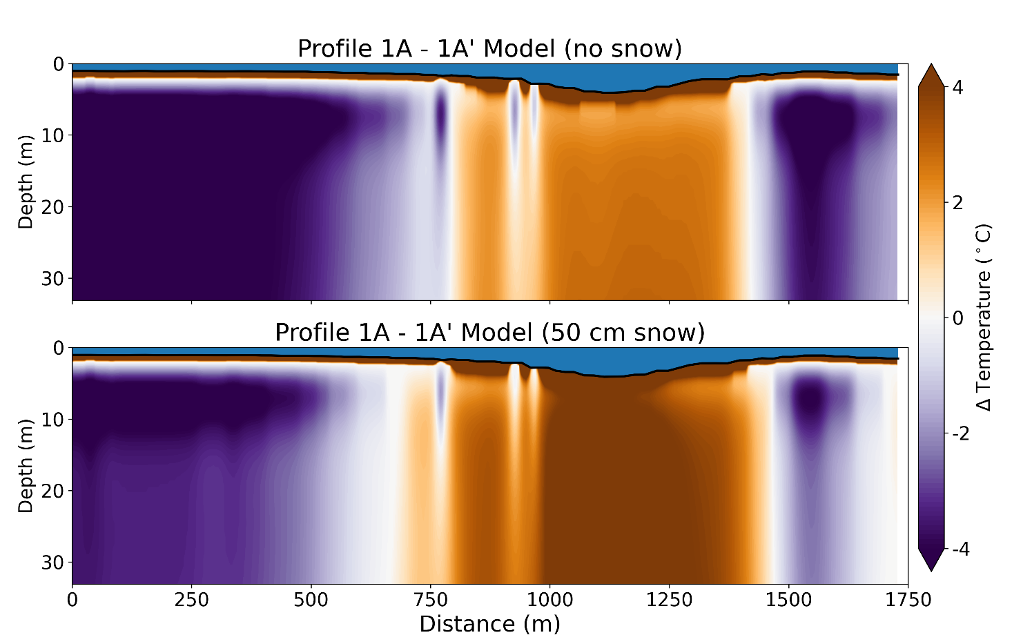

**Supplementary Figure 5**: Modelled sediment temperature along Profile 1A - 1A’ for two snow depth scenarios: no snow (upper figure) and 50 cm snow (lower figure).

## Supplementary Figures



**Supplementary Figure 1.** The figure legends are required to have the same font as the main text, 12 point normal Times New Roman, single spaced. Please use a single paragraph for each legend and prepare the figures keeping in mind the PDF layout.